Dispersion analysis of a beam-based lattice

Run the analysis

The macros in this folder simulate the dispersion curves of a square lattice, to find the existence of bandgaps.

First, open Ansys, make sure that the **Ansys** directory is the same directory where the macros are stored (file>change directory).

You can also change the jobname (file>change the jobname).

Now, **write in the command line *main****.* This will run the macros: geom, matandmesh, and loop.

You will obtain the dispersion curves of the square lattice. Depicted in the **Figure 1**.

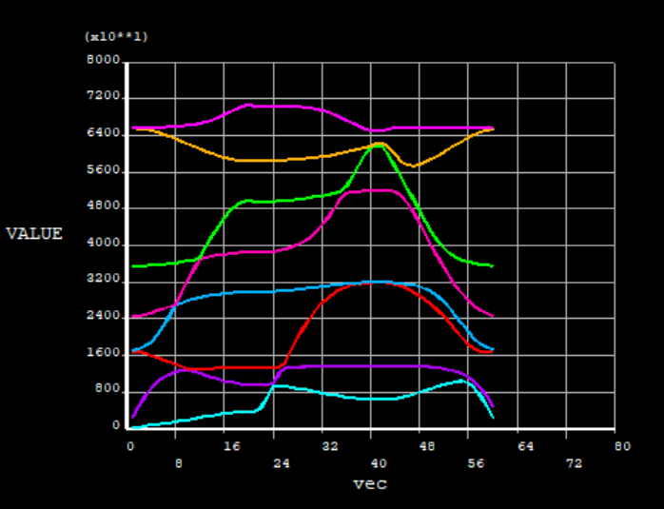

***Figure 1*** *Dispersion curve for a square beam-based Honeycomb. The simulation was run using E=2000 MPa, L=10mm, d=1 mm, ro = 1e-9 Tn/mm3, 10 elements per beam, and 20 datapoints per direction (total of 60).*

The first 8 eigenfrequencies are extracted and plotted in the dispersion relation (Figure 1), more eigenfrequencies can be extracted by incrementing the number “nmodes”. Each direction of the Brillouin zone is discretized in 20 datapoints (one can change this number at the beginning of the simulation, np, number of datapoints). For each point in the Brillouin zone, the eigenfrequency of each mode is obtained and stored in the variable F(datapoint,mode). In the next section concepts like Brillouin zone are explained.

If you write in the command line ***\*Status,F*** you will obtain the variable F listed in the following way: the first column is the datapoint, in our case from 1 to 21 goes from G to X in the Brillouin zone, from 21 to 41 is from X to M, and 41 to 61 is from M to G; the second is the mode, the third is the step, which is always 1; an the fourth is the eigenfrequency.

You can also run the macro *singlemode* to obtain the modal results in a particular datapoint. This way you can see how the modes look like at a specific point in the Brillouin zone.

Explanation of the Bloch boundary conditions

In this section, the finite elements implementation of the Bloch-wave theorem [1] that is used to compute the wave propagation characteristics (the band structure) of the periodic materials is presented. This approach has been previously used by a number of researchers to compute the wave propagation response in periodic structures.[2,3] Here, we summarize the methodolgy for completeness.

In infinite periodic structures, elastic waves do not propagate as simple plane waves, but rather as Bloch waves.[1] A Bloch wave can be described by the expression:



where ***k*** is the wave vector, inversely proportional in magnitude to the wavelength , is the angular frequency, and  is a periodic complex-valued vector function with the same spatial periodicity as the metamaterial. Therefore, for any pair of periodically located lattice points at a distance ***R***, we have:



As  and  are periodically located, for a 2D lattice we can express , with *n* and *m* arbitrary integers, and  and the primitive vectors of the lattice. In 2D, the *reciprocal* lattice primitive vectors are related to the lattice primitive vectors through the following relationships:[4]



where . The set of all reciprocal lattice vectors (i.e., the set of vectors where  and  are any integers) denotes the entire set of wave vectors that can satisfy the periodicity of the lattice. The set of wave vectors, , required to completely describe the propagation of electromagnetic waves in two-dimensional photonic crystals is referred to as the Brillouin zone.[5] The Brillouin zone for a square lattice is shown in **Figure 4**.

Consider the schematic in **Figure 2**, which represents 4 adjacent unit cells. While only 8 nodes are shown on the boundary of each cell for simplicity, this description is general and applies to cells with arbitrary numbers of nodes. As the boundary nodes are shared by multiple cells, the displacement of the nodes at the top boundary of cell (m,n) must be the same as the displacement of the nodes at the bottom boundary of cell (n,m+1); similarly, the displacement of the nodes at the right boundary of cell (m,n) must be the same as the displacement of the nodes at the left boundary of cell (n+1,m); finally, the displacement of node nTR (node at the top right corner) of cell (m,n) must be the same as the displacement of node nBL (node at the bottom left corner) of cell (n+1,m+1). Hence:



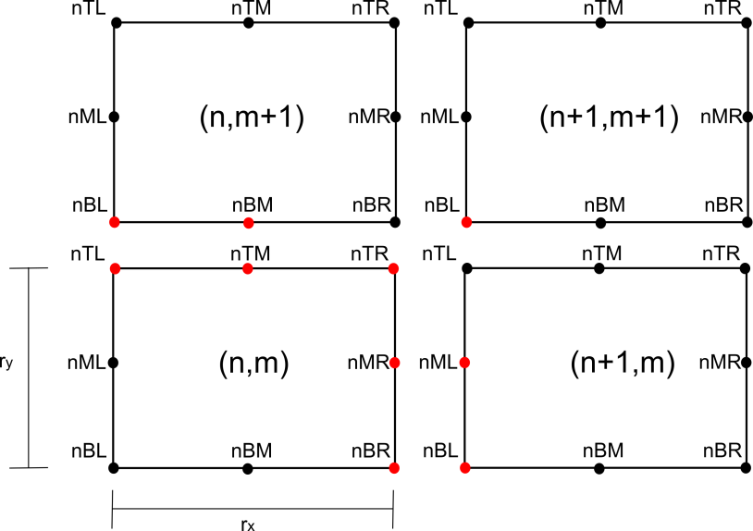

*Figure 2 Schematic of the Bloch-periodic boundary conditions applied to calculate the band structure of the proposed metamaterial (a 2 X 2 unit cell is shown). The nodes depicted in red indicate active couplings.*

By applying Bloch periodicity, these conditions can be written as:



where is the wave vector, rx and ry are the x- and y-dimensions of the unit cell, and **e1** and **e2** are the base vectors of the reference system. These equations are called Bloch-periodic boundary conditions and must be enforced at any boundary node of the unit cell. Notice that these conditions are complex-valued, which presents a challenge for implementation in commercial Finite Elements software packages. To overcome this problem, it is convenient to separate the real and imaginary parts of the boundary conditions.[6] For example, the condition , can be expressed as:



If we express the real parts of the displacements as and , and the imaginary parts of the displacements as and , we finally obtain:



To apply these real-valued boundary conditions, we model two identical unit cells, with the same mesh, in the same simulation but not physically connected. One unit cell represents the real part of the displacements, while the other represents the imaginary part of the displacements; see **Figure 3**. The Bloch-periodic boundary conditions are then reduced to displacement couplings between pairs of nodes on the two different meshes, which are easily implemented in commercial finite elements packages.

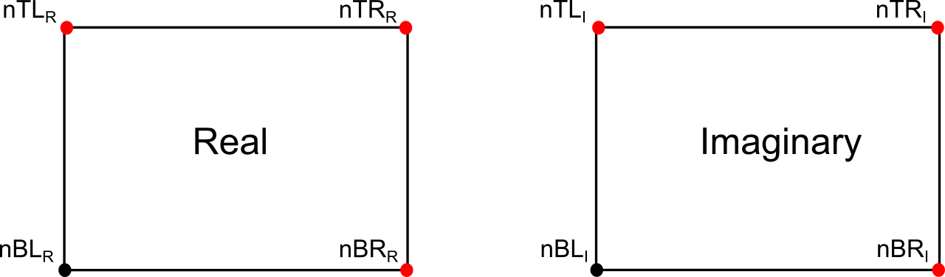

***Figure 3*** *Schematics of the FEA implementation of the Bloch-periodic boundary conditions applied to calculate the band structure of the proposed metamaterial. Two separate FEA models capture the real and imaginary components of the displacement, connected by conditions at the nodes depicted in red.*

A consequence of duplicating the model, separating for the real and imaginary values of the displacements, is that each eigenfrequency will have two symmetric eigenmodes, so the actual eigenmode is Ureal+i*Uimaginary.

To calculate the dispersion relation for a periodic material, like a square honeycomb, we solve the eigenvalue problem detailed above with the finite elements package Ansys. The eigenfrequency solver is used. The analysis type is Modal, and the mode extraction method is Subspace. The **k** vector is swept along the boundaries of the triangular region embedded in the Brillouin cell (Figure 4), that is:

* From to
* From to
* From to

The first 8 eigenfrequencies are extracted and plotted in the dispersion relation (Figure 1), more eigenfrequencies can be extracted by incrementing the number “nmodes”. Each direction of the Brillouin zone is discretized in 20 datapoints (one can change this number at the beginning of the simulation, np, number of datapoints). For each point in the Brillouin zone, the eigenfrequency of each mode is obtained and stored in the variable F(datapoint,mode).

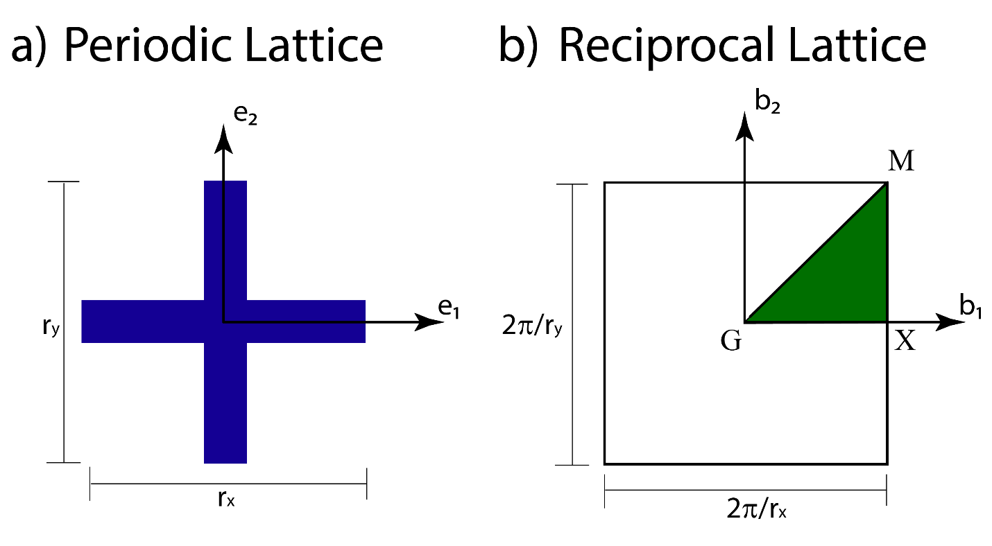

*Figure S13 a) Representation of the unit cell of the Square honeycomb in Cartesian coordinates. b) The reciprocal lattice in the Fourier space, and its dimensions. The green area is the irreducible Brillouin zone, limited by points G, X, and M.*

Explanation of each macro

Geom

Generates the geometry. Important commands:

* k,1,-10,10,0 -> creates keypoint 1 at the location x=-10, y=10, z=0
* l,1,2 -> creates line from keypoint 1 to keypoint 2
* *ask,L,length,10 -> prompts a window to ask the user “length”, stores the value in a variable “L”, if user presses enter without filling any value the default length will be 10.

Matandmesh

Creates the mesh. Important commands:

* et,1,beam188 -> creates element type 1 as shell188
* sectype,1,beam,rect -> creates a rectangular section for the beam
* secdata,d,1 -> assigns height d to the section and depth 1
* mp,ex,1,E -> Assigns Young’s modulus E for material 1.
* mp,nuxy,1,0.3 -> Poisson ration equals 0.3.
* mp,dens,1,ro -> Assigns density ro to material 1.
* lsel,all -> select all lines
* latt,1,1,1, , , ,1 -> assigns material 1, element type 1, and section type 1 to the unmeshed lines.
* esize,,ne -> assigns number of elements per line “ne”
* lmesh,1,8 -> Mesh lines
* nsel,s,loc,x,0 -> select nodes located at x=0
* nsel,r,loc,y,0.5*L -> among the selected nodes, select the node located at y=0
* *get,ntreal,node,,num,max -> assign ntreal = number of the selected node

Loop

Creates the Bloch boundary conditions, and solves for each boundary condition. Important commands:

* *dim,F,table,3*np+1,nmodes -> creates a variable F of dimension (3*np+1,nmodes)
* *do,i,1,3*np+1 -> loop, repeat the commands inside the *do loop sweeping values of *i* from 1 to 3*np+1
* ce,1,0,ntreal,ux,1,nbreal,ux,-cos(ky),nbimag,ux,sin(ky) -> Define the constrain equation number 1. The equation is the following ux(ntreal)*1- ux(nbreal)* cos(ky)+ ux(nbimag)* sin(ky)=0
* MODOPT,Subsp,2*nmodes,0,0,,OFF -> select the solver type subspace, solve for the first 2*nmodes
* *get,Fv,active,0,set,freq -> store the eigen frequency of the active substep in the variable Fv

Singlemode

Solves for a particular datapoint of the Brillouin zone, this way one can visualize the different modes. Keep in mind that for every eigenfrequency you will obtain two symmetric eigenmodes, so if you want to see the deformation of the 6th mode, plot the deformed shape o the 11 and 12 substep.

References

[1] F. Bloch, *Z. Für Phys.* **1929**, *52*, 555.

[2] M. S. Kushwaha, P. Halevi, L. Dobrzynski, B. Djafari-Rouhani, *Phys. Rev. Lett.* **1993**, *71*, 2022.

[3] P. Wang, J. Shim, K. Bertoldi, *Phys. Rev. B* **2013**, *88*, 014304.

[4] M. Maldovan, E. L. Thomas, *Periodic Materials and Interference Lithography*, Wiley-VCH Verlag GmbH & Co. KGaA, Weinheim, Germany, **2008**.

[5] L. Brillouin, *Wave Propagation in Periodic Structures: Electric Filters and Crystal Lattices*, Dover Publications, **1953**.

[6] M. Åberg, P. Gudmundson, *J. Acoust. Soc. Am.* **1997**, *102*, 2007.